

PAIA MANUAL

Prepared in terms of section 51 of the Promotion of Access to Information Act 2 of 2000 (as amended)

TABLE OF CONTENTS

- List of Acronyms and abbreviations
- Purpose of PAIA Manual
- Key Contact details for access to information
- Guide on how to use PAIA and how to obtain access to the Guide
- Categories of records of CTS brokers which are available without requesting access
- Description of the records which are available in accordance with any other legislation
- Description of the subjects on which the body holds records and categories of records held on each subject
- Processing of personal information
- Availability of the manual

LIST OF ACRONYMS AND ABBREVIATIONS

  - “CEO” Chief Executive Officer

  - “DIO” Deputy Information Officer;

  - “IO“ Information Officer;

  - “Minister” Minister of Justice and Correctional Services;

  - “PAIA” Promotion of Access to Information Act No. 2 of 2000( as
Amended;

  - “POPIA” Protection of Personal Information Act No.4 of 2013;

  - “Regulator” Information Regulator; and

  - “Republic” Republic of South Africa

PURPOSE OF PAIA MANUAL

This PAIA Manual is useful for the public to-

  - check the categories of records held by a body which are available without a person having to submit a formal PAIA request;

  - have a sufficient understanding of how to make a request for access to a record of the body, by providing a description of the subjects on which the body holds records and the categories of records held on each subject;

  - know the description of the records of the body which are available in accordance with any other legislation;

  - access all the relevant contact details of the Information Officer and Deputy Information Officer who will assist the public with the records they intend to access;

  - know the description of the guide on how to use PAIA, as updated by the Regulator and how to obtain access to it;

  - know if the body will process personal information, the purpose of processing of personal information and the description of the categories of data subjects and of the information or categories of information relating thereto;

  - know the description of the categories of data subjects and of the information or categories of information relating thereto;

  - know the recipients or categories of recipients to whom the personal information may be supplied;

  - know if the body has planned to transfer or process personal information outside the Republic of South Africa and the recipients or categories of recipients to whom the personal information may be supplied; and

  - know whether the body has appropriate security measures to ensure the confidentiality, integrity and availability of the personal information which is to be processed.

KEY CONTACT DETAILS FOR ACCESS TO INFORMATION OF CTS Brokers PTY LTD

  - Chief Information Officer

Name: Andries Jacobus Greyling
Tel: 0861 333 403
Email: andre@cts-brokers.co.za
Fax number: NA

  - Deputy Information Officer (NB: if more than one Deputy Information Officer is designated, please provide the details of every Deputy Information Officer of the body designated in terms of section 17 (1) of PAIA.

Name: Sandi Stehlik
Tel: 0861 333 403
Email: manager@cts-brokers.co.za
Fax Number: NA

  - Access to information general contacts

Email: info@cts-brokers.co.za

  - National or Head Office

Postal Address: Postnet Suite 2, Private Bag X9, Postnet, Flamwood, KLD, 2572

Physical Address: Corpus Novem Park 84, Yusuf Dadoo, Wilkoppies, KLD, 2571

Telephone: 0861 333 403

Email: info@cts-brokers.co.za

Website: www.cts-brokers.co.za

GUIDE ON HOW TO USE PAIA AND HOW TO OBTAIN ACCESS TO THE GUIDE

  - The Regulator has, in terms of section 10(1) of PAIA, as amended, updated and made available the revised Guide on how to use PAIA (“Guide”), in an easily comprehensible form and manner, as may reasonably be required by a person who wishes to exercise any right contemplated in PAIA and POPIA.

  - The Guide is available in each of the official languages and in braille.

  - The aforesaid Guide contains the description of-

    - the objects of PAIA and POPIA;

    - the postal and street address, phone and fax number and, if available, electronic mail address of-

      - the Information Officer of every public body, and

      - every Deputy Information Officer of every public and private body designated in terms of section 17(1) of PAIA and section 56 of POPIA;

    - the manner and form of a request for-

      - access to a record of a public body contemplated in section 11; and

      - access to a record of a private body contemplated in section 50;

    - the assistance available from the IO of a public body in terms of PAIA and POPIA;

    - the assistance available from the Regulator in terms of PAIA and POPIA;

    - all remedies in law available regarding an act or failure to act in respect of a right or duty conferred or imposed by PAIA and POPIA, including the manner of lodging-

      - an internal appeal;

      - a complaint to the Regulator; and

      - an application with a court against a decision by the information officer of a public body, a decision on internal appeal or a decision by the Regulator or a decision of the head of a private body;

    - the provisions of sections 14 and 51 requiring a public body and private body, respectively, to compile a manual, and how to obtain access to a manual;

    - the provisions of sections 15 and 52 providing for the voluntary disclosure of categories of records by a public body and private body, respectively;

    - the notices issued in terms of sections 22 and 54 regarding fees to be paid in relation to requests for access; and

    - the regulations made in terms of section 92.
  - Members of the public can inspect or make copies of the Guide from the offices of the public and private bodies, including the office of the Regulator, during normal working hours.

  - The Guide can also be obtained-

    - upon request to the Information Officer;

    - from the website of the Regulator (https://www.justice.gov.za/inforeg/).

  - A copy of the Guide is also available in the following official language , for public inspection during normal office hours-

    - Specified languages: English

- CATEGORIES OF RECORDS OF THE CTS Brokers PTY LTD WHICH ARE AVAILABLE WITHOUT A PERSON HAVING TO REQUEST ACCESS

Category of records | Types of the Record | Available on Website | Available upon request
Privacy policy |  | X | X

DESCRIPTION OF THE RECORDS OF CTS Brokers PTY LTD WHICH ARE AVAILABLE IN ACCORDANCE WITH ANY OTHER LEGISLATION
Category of Records | Applicable Legislation
Memorandum of incorporation | Companies Act 71 of 2008
PAIA Manual | Promotion of Access to Information Act 2 of 2000

DESCRIPTION OF THE SUBJECTS ON WHICH THE BODY HOLDS RECORDS AND CATEGORIES OF RECORDS HELD ON EACH SUBJECT BY THE CTS Brokers PTY LTD

Subjects on which the body holds records | Categories of records
Strategic Documents | Annual Reports
Human Resources | - HR policies and procedures  - Employees records

PROCESSING OF PERSONAL INFORMATION

  - Purpose of Processing Personal Information
CTS Brokers PTY LTD collect personal information to enable to provide accurate quotes / information to current and perspective clients.

  - Description of the categories of Data Subjects and of the information or categories of information relating thereto

Categories of Data Subjects | Personal Information that may be processed
Customers / Clients | name, address, registration numbers or identity numbers, employment status and bank details
Service Providers | names, registration number, vat numbers, address, trade secrets and bank details
Employees | address, qualifications, gender and race

  - The recipients or categories of recipients to whom the personal information may be supplied

Category of personal information | Recipients or Categories of Recipients to whom the personal information may be supplied
Identity number and names, for criminal checks | South African Police Services
Qualifications, for qualification verifications | South African Qualifications Authority
Credit and payment history, for credit information | Credit Bureaus

  - Planned transborder flows of personal information – Not applicable to CTS Brokers PTY LTD

  - General description of Information Security Measures to be implemented by the responsible party to ensure the confidentiality, integrity and availability of the information
Anti virus and Anti – malware Solutions.

- AVAILABILITY OF THE MANUAL

  - A copy of the Manual is available-

    - on www.cts-brokers.co.za if any;

    - head office of the CTS Brokers PTY LTD for public inspection during normal business hours;

    - to any person upon request and upon the payment of a reasonable prescribed fee; and

    - to the Information Regulator upon request.

  - A fee for a copy of the Manual, as contemplated in annexure B of the Regulations, shall be payable per each A4-size photocopy made.

- UPDATING OF THE MANUAL

The head of a CTS Brokers PTY LTD will on a regular basis update this manual.

Issued by

___________________________________________________
Andre Jacobus Greyling
Managing Director

FORM 2
REQUEST FOR ACCESS TO RECORD
[Regulation 7]

NOTE:

1.Proof of identity must be attached by the requester.
2.If requests made on behalf of another person, proof of such authorisation, must be attached to thisform.

TO: The Information Officer
______________________
______________________
______________________
______________________
(Address)
E-mail address:_____________________________
Fax number: _____________________________

Mark with an "X"
Request is made in my own name Request is made on behalf of another person
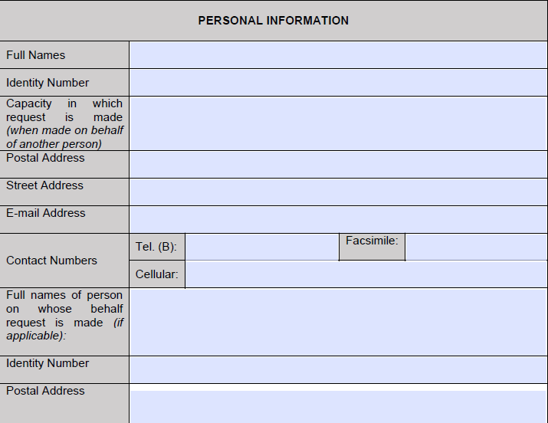
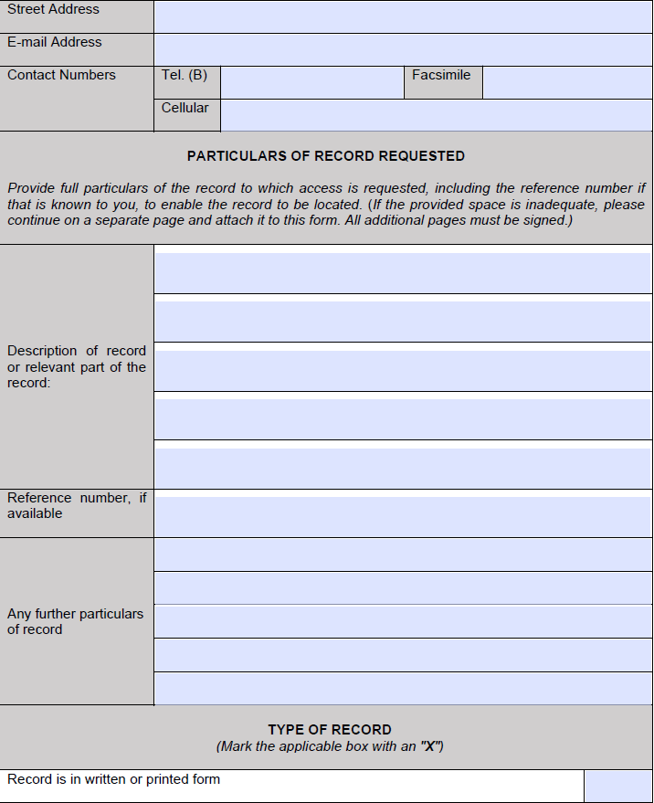
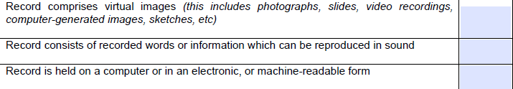

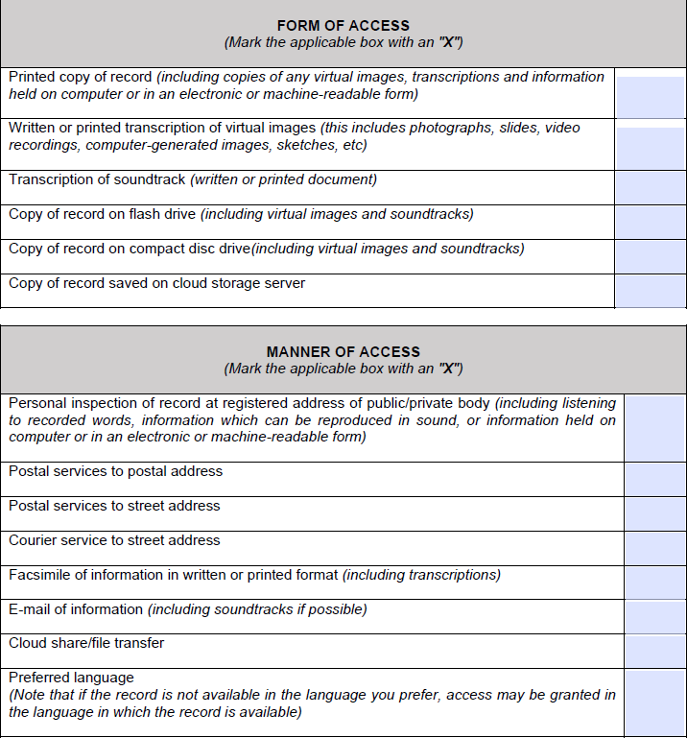
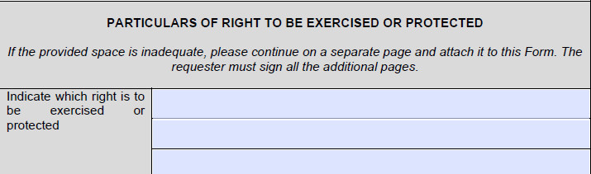

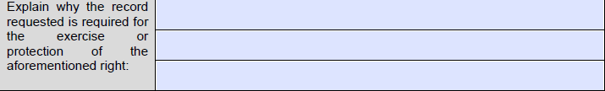
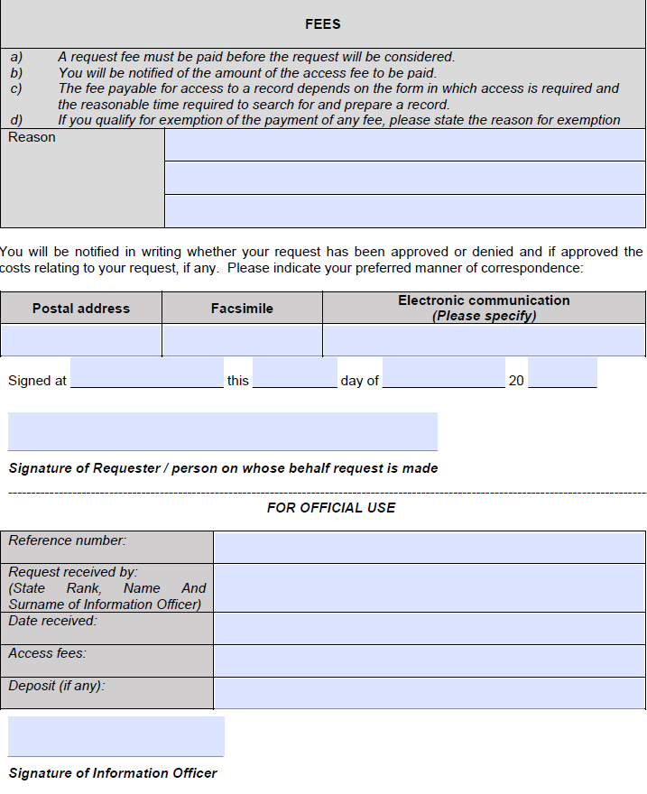

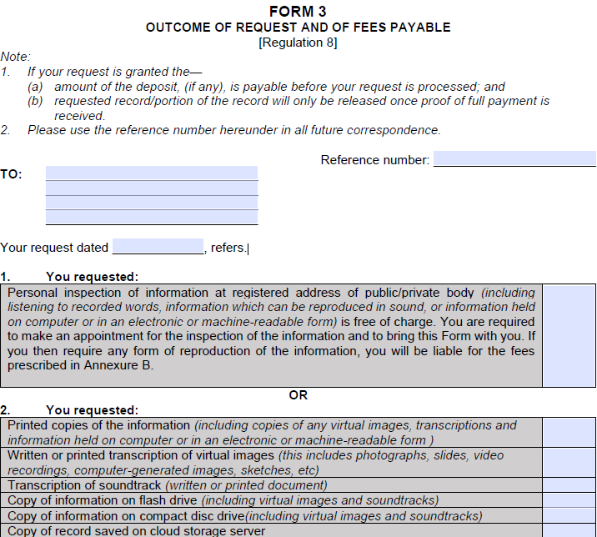
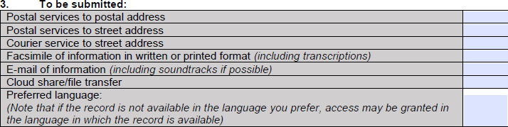


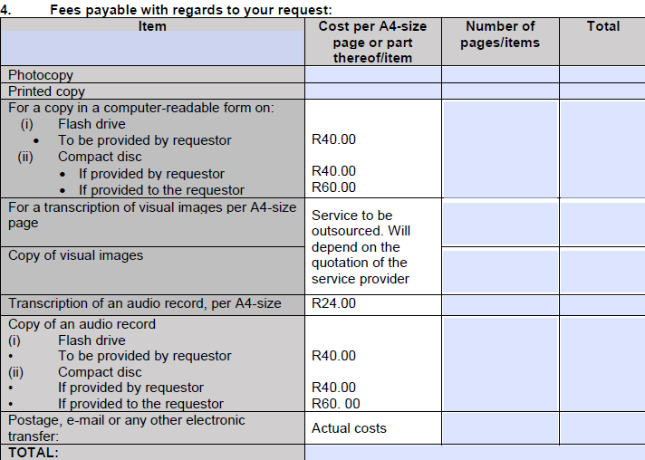
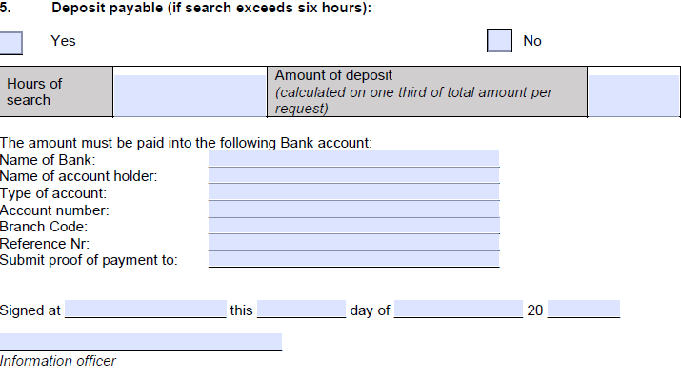

INTERNAL APPEAL FORM
FORM 4
[Regulation 9]

Reference Number: ………………………………..

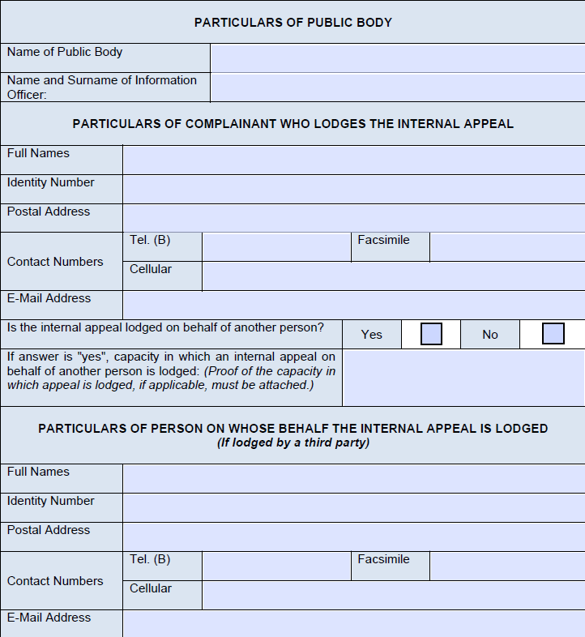
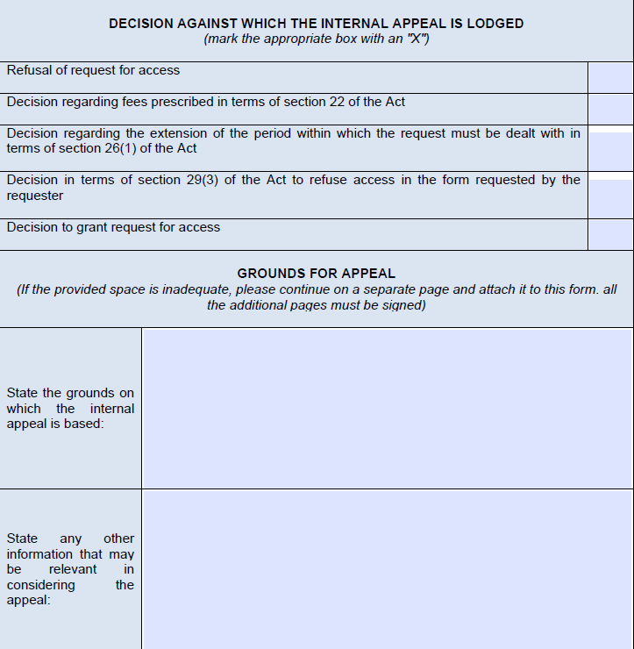
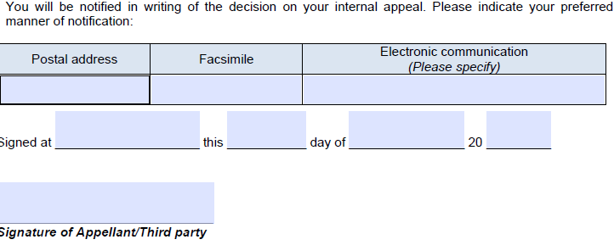

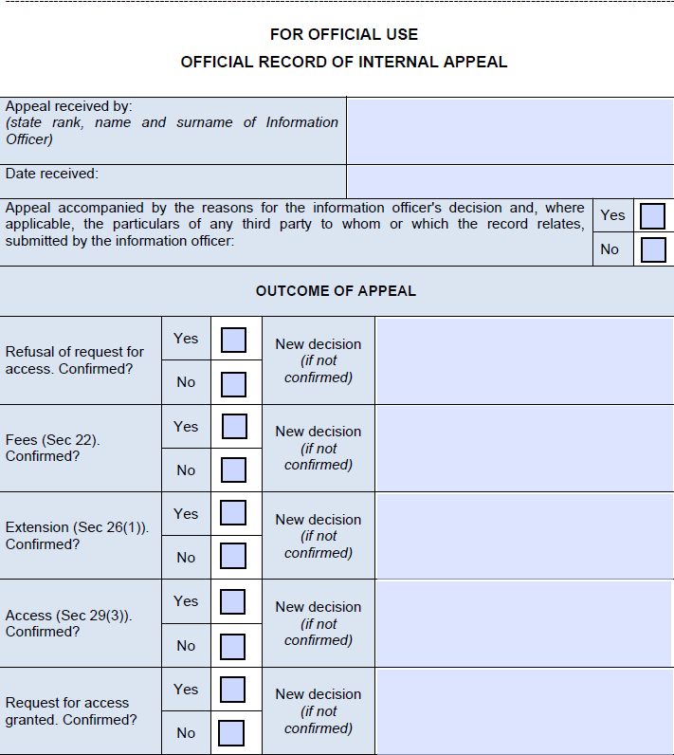


Section 17(1) of PAIA- For the purposes of PAIA, each public body must, subject to legislation governing the employment of personnel of the public body concerned, designate such number of persons as deputy information officers as are necessary to render the public body as accessible as reasonably possible for requesters of its records.
Section 56(a) of POPIA- Each public and private body must make provision, in the manner prescribed in section 17 of the Promotion of Access to Information Act, with the necessary changes, for the designation of such a number of persons, if any, as deputy information officers as is necessary to perform the duties and responsibilities as set out in section 55(1) of POPIA.
Section 11(1) of PAIA- A requester must be given access to a record of a public body if that requester complies with all the procedural requirements in PAIA relating to a request for access to that record; and access to that record is not refused in terms of any ground for refusal contemplated in Chapter 4 of this Part.
Section 50(1) of PAIA- A requester must be given access to any record of a private body if- - that record is required for the exercise or protection of any rights; - that person complies with the procedural requirements in PAIA relating to a request for access to that record; and - access to that record is not refused in terms of any ground for refusal contemplated in Chapter 4 of this Part.
Section 14(1) of PAIA- The information officer of a public body must, in at least three official languages, make available a manual containing information listed in paragraph 4 above.
Section 51(1) of PAIA- The head of a private body must make available a manual containing the description of the information listed in paragraph 4 above.
Section 15(1) of PAIA- The information officer of a public body, must make available in the prescribed manner a description of the categories of records of the public body that are automatically available without a person having to request access
Section 52(1) of PAIA- The head of a private body may, on a voluntary basis, make available in the prescribed manner a description of the categories of records of the private body that are automatically available without a person having to request access
Section 22(1) of PAIA- The information officer of a public body to whom a request for access is made, must by notice require the requester to pay the prescribed request fee (if any), before further processing the request.
Section 54(1) of PAIA- The head of a private body to whom a request for access is made must by notice require the requester to pay the prescribed request fee (if any), before further processing the request.
Section 92(1) of PAIA provides that –“The Minister may, by notice in the Gazette, make regulations regarding- (a) any matter which is required or permitted by this Act to be prescribed; (b) any matter relating to the fees contemplated in sections 22 and 54; (c) any notice required by this Act; (d) uniform criteria to be applied by the information officer of a public body when deciding which categories of records are to be made available in terms of section 15; and (e) any administrative or procedural matter necessary to give effect to the provisions of this Act.”

